Iam 14 year old

This is my teenage. My teenage is full of happiness and sadness. I am in 9th standard now. my favorite year was 2022 when I as in 8th standard. When I was in 8th i got true best friend I understood the value of a true friend. So myself charlotte. My happiness started when I was in 8th standard and ended when I became in 9th standard as I changed my school. In previous year I was in global Indian international national school (GIIS) one of my favorite schools . I had lot of memories in there with my friends. The teacher were so friendly. We used to bunk classes. It was the best year.

On June 20th,2022 at morning. I was sitting in the car. It’s my first time at GIIS. I'm feeling quite anxious. I have finally reached there. I was feeling so nervous at the time that I wondered if I had briefly vanished. As soon as I arrived at the school, a teacher escorted me to my class. Now I'm in front of my class, I prayed, "God, make me invisible." I take a deep breath and grab the door's handle before walking in. When I walked in, there were two and three other students. They inquired whether I was a new student, and I replied "yes." They said, "that's your seat" and I went and sat there.

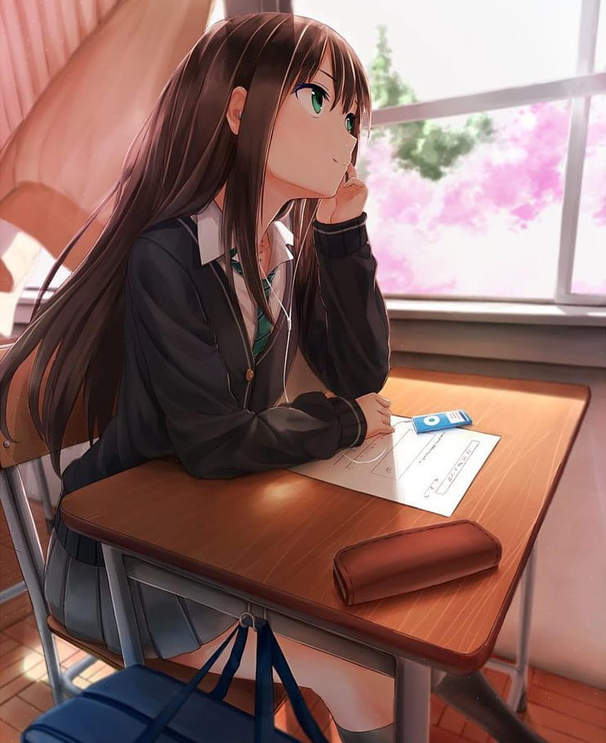

After some time, Jane, a girl, approached me and inquired about me. We had some brief conversation. The bell rung at that same time.

The teacher showed up. Not gonna lie, my class teacher is stunning. When it was time for attendance, the teacher asked me "which school you studied in before," and I said "I studied in my country." After the teacher left, Sarah, my first friend in that school, arrived and sat next to me. Following this, she inquired about me and my interests before asking, "Have you ever had a crush on anyone?" We both made such polite conversation.

time skipped

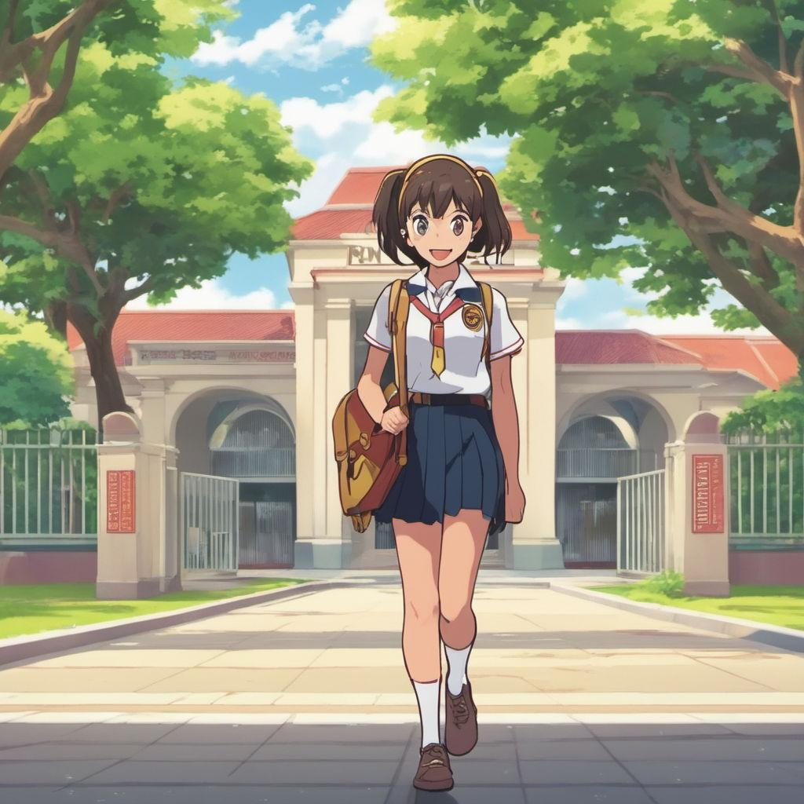

Now when it was time to disperse, I boarded my bus, sat down, and fell asleep. My home has been in. After taking a long bath, I slept off briefly. As I lay in bed at night after eating and getting ready for bed, I was reflecting on the day. The finest school ever is this one. .

Next day

It's currently arabic period . The second to last day of classes is today, after which there will be a summer break. Therefore, the teacher agreed to let us have a party tomorrow. It'll be enjoyable. I need to get chocolates for my classmates . I returned home and asked my mother to bought me a chocolate packet for my classmate.

The next day .

I went to school. Everyone purchased food, chocolate, and chips. since there were so many balloons placed throughout the campus, making it seem fantastic. We had fun at the wonderful celebration. It was quite lovely. I returned home joyfully .

The next morning:

My temperature was quite high. My health is not great. Even in my bed, I can't even rise up. By the way, my mother informed me that I would be visiting my homeland as it would be a wonderful vacation for us.

The next day

I'm leaving for my homeland today. I'm quite happy. After three years, I'm returning home. My cousins are more enthusiastic than I am. they are now getting to meet me after years. Now we're heading to the airport.

At flight

It is quite dull. After they delivered a cup of noodles for me to eat, I eat since I was really hungry. After several hours, I finally arrived there. I can hardly wait to visit my cousins. I exited the airport. I visited my cousins and aunt. After seeing me, they started to get really emotional. After 3 years, they are still seeing me. The changes they had astonished me. small cousin sister of my. She grew to be so huge. She was just three years old the last time I saw her, and she is now six. My cousin brother, he turned 18,who was 15 years old, showed such maturity. And my aunt, who was before a bit chubby and attractive, become very pale. We talked for bit and headed towards the home.

At home

At home, we arrived. I felt so worn out. You look very exhausted, my grandmother commented. "Go rest your body." however, am not interested in relaxing. I'd want to have fun. I'm returning to my native nation after several years. This month-long vacation must be enjoyed.

After many days

I just met all of my family, both known and unknown. My grandma forced me to meet my distant relatives, some of them I even don't know, thus these days were boring because of it. However, my aunt did mention that we were going on a trip. There are barely two days left till our departure.

Trip day

The time is early on Saturday. I'm preparing for the journey. Already present were my cousins and aunties. Once ready, we snapped a picture and set off on our journey. following a very long time. We reached our destination. Our trip was to a forested region with significant water falls and mountains. We made a resort reservation. We went to the resort. Inside of a forest, our resort was located. The rainfall was intense. Once we were dressed comfortably, we walked to our room. Can we go to the pool, I asked my cousins, but my grandmother answered "it's raining," so we were not allowed. Playing while it's raining. You'll have a fever. but it's okay, let them play, my auntie reassured me. Allow them to enjoy themselves. She said . We let out a loud yell. and sprinted over to the pool before diving in.

While it rained, we played in the pool.

It was incredibly enjoyable. after engaging in a game of pool. To go out, we dressed into decent clothing.

We ventured outside and had fun. I did, in fact, zipline through the waterfall. We had a wonderful time on this 2-day excursion. The trip was fantastic.

After reaching home

The journey was enjoyable.We had a good time. However, it did not remain for very long. My mother said that "School is restarting. I have a lot of holiday homework to complete. She purchased airline tickets for us to return to the UAE". I felt very sad. My cousins, aunties, and the homemade meals my grandma cooked will all be missed. I will miss everything.

At the day of going back

All of my family members are here at this time. I'm getting ready with a sorrowful expression on my face.

I bid goodbye to everyone at the airport.My young cousin was barely holding back her tears. Her face is hidden from view. I entered the airport with a sorrowful heart.

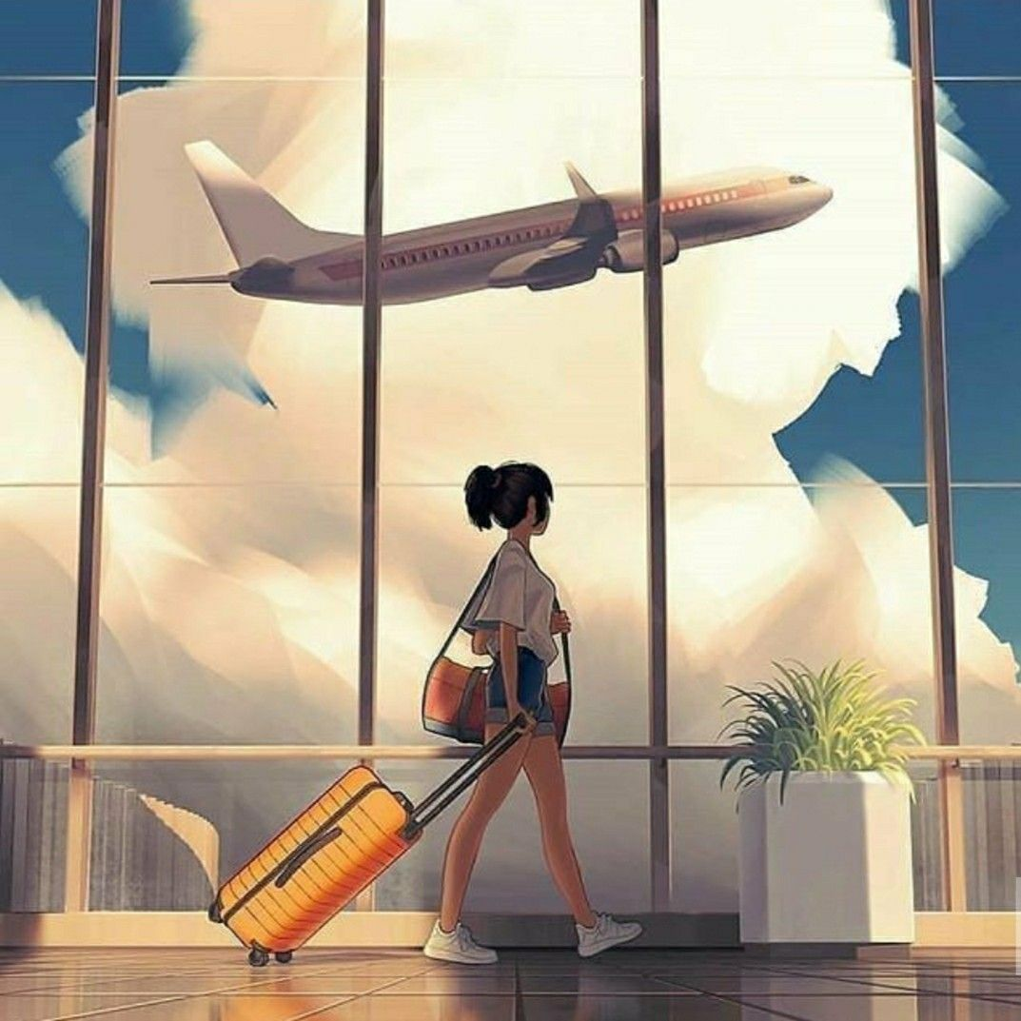

After reaching in uae

inside the vehicle We arrived here late at night. My mood is not good right now. To brighten my mood, I gazed out the window.

When we arrived at our house, I went straight to my bed and fell asleep.

After days

Today My father is relocating to another nation for work. Which makes me even sadder. But I made up my mind by declaring, "He'll be working for me and my sister." "I should be proud of him."

On the day of school reopening

Next part coming soon